

*Department of Computer Science & Engineering*

*Program: B.Sc. in CSE*

***Course Code****: CSE-3634*

***Course Title****: Computer Networks Lab*

*Lab Report on*

*“Smoke Detection and Fire Prevention using Cisco Packet Tracer”*

***Submitted By:***

Group 1

Group member one:

Group member two:

Group member three:

Section:

***Submitted To:***

*****

Adjunct Lecturer, CSE

International Islamic University Chittagong



Date of Submission: 21/05/2023

|  |  |  |
| --- | --- | --- |
| Sl no. | Topic | Page |
| 1 | Introduction | 2 |
| 2 | Literature Review | 2 |
| 3 | Problem Description | 3 |
| 4 | Application | 3 |
| 5 | Methodology | 4 |
| 6 | Implementation | 7 |
| 6.1 Network Design | 7 |
| 6.2 Configuration | 7 |
| 6.3 Conditions | 10 |
| 7 | Result Analysis | 11 |
| 7.1 When smoke level is less than 0.5 | 11 |
| 7.2 When smoke level is more than 0.5 | 11 |
| 8 | Conclusion | 12 |
| 9 | References | 12 |

*Table of Contents*

*List of Figures*

|  |  |  |
| --- | --- | --- |
| Figure No. | Figure Name | Page |
| Figure 6.1. | Network Design | 7 |
| Figure 6.2. | System Conditions based on Situation | 10 |
| Figure 7.1. | System when fire not detected | 11 |
| Figure 7.2. | System when fire detected | 11 |

*List of Tables*

|  |  |  |
| --- | --- | --- |
| Table No. | Table Name | Page |
| Table.1 | Components of Proposed Smoke Detector and Fire Prevention System | 6 |

1. *Introduction*

For a very long time, people have severely damaged the environment, but thanks to technical breakthroughs, we may now attempt to repair it. To prevent property loss as a result of fire accidents, both naturally occurring and artificially caused, it is essential to detect fire in homes and industries. The ability to recognize fire can be crucial since it can be the difference between life and death. A fire alarm system helps keep everyone safe because fires can start from anywhere and at any time.

A smoke detecting system will notify the individual as well as take necessary actions in the home to prevent the fire from spreading. In our proposed system, we use the Internet of Things as the technology and a smoke sensor to alert various home appliances to take the proper action to put out the fire. The system is useful since it alerts the household appliances to act as needed in addition to buzzing an alarm.

We have used cisco packet tracer which is a network simulator and this software provides a wide range of Cisco switches, routers and wireless devices. Cisco packet tracer provides physical simulation as well as an assessment tool and the assessment tools can be used to create practical networking models.

1. *Literature Review*

Fires disturb daily life in a terrible way and inflict significant damage. Therefore, it is of utmost importance to stop them or lessen their consequences. False alarms are a barrier that has yet to be overcome, despite the fact that numerous solutions have been developed to address this issue. Our model, which consists of a smoke sensor, has been set to a limit of 0.5, indicating that necessary action will be done if the smoke level detected by the sensor exceeds the level set. This may fluctuate depending on the individual's preferences, the circumstances, or the environment. Furthermore, only a small number of appliances are activated by the smoke sensor; these can be modified. When the smoke level rises above the set threshold, windows, doors, and garage doors open. To stop the spread of fire throughout the house, the sprinklers also begin to spray water.

1. *Problem Description*

The project aims to create a smart smoke detection system with integrated fire prevention measures. Traditional smoke detectors can only detect smoke but lack the ability to take immediate action to prevent fires. This project seeks to develop an intelligent system that accurately detects smoke in diverse environments and triggers proactive measures to minimize or eliminate fire risks. The system will integrate with other devices and systems, such as fire suppression and emergency services, to ensure a coordinated and rapid response during fire emergencies. The objective is to enhance safety, prevent property damage, and save lives by effectively detecting and preventing fires before they escalate.

1. *Application*

The project "Smoke Detection with Fire Prevention" has numerous potential applications. Here are a few short examples:

1. Residential Buildings: Smoke detectors are a common safety feature in residential buildings, but integrating fire prevention mechanisms takes it a step further. The system can detect smoke and trigger actions such as activating fire sprinklers, closing off ventilation systems, and automatically notifying emergency services to prevent the spread of fire and minimize damage.

2. Industrial Facilities: Industrial environments often deal with hazardous materials and complex machinery, making fire prevention crucial. By implementing smoke detection with fire prevention systems, companies can enhance their safety protocols. The system can quickly identify smoke, trigger alarms, shut down specific equipment, and activate fire suppression systems to prevent or contain fires before they escalate.

3. Data Centers: Data centers house valuable and sensitive equipment, including servers and storage devices. Smoke detection combined with fire prevention measures can help safeguard these critical assets. Rapid smoke detection can prompt the system to isolate affected areas, cut off power supply, and trigger fire suppression systems to minimize equipment damage and data loss.

4. Warehouses: Warehouses often store large quantities of goods, which can be highly flammable. Smoke detection with fire prevention can help mitigate the risk of fire outbreaks. The system can detect smoke, trigger alarms, and activate fire suppression systems, reducing the potential damage to stored goods and ensuring the safety of warehouse staff.

5. Public Spaces: Implementing smoke detection with fire prevention in public spaces such as shopping malls, airports, and entertainment venues can enhance overall safety. The system can detect smoke, activate evacuation protocols, notify authorities, and provide real-time information to guide people to safety.

6. Vehicles: Smoke detection with fire prevention can also be applied to vehicles, such as cars, buses, and trains. By installing smoke detectors and fire prevention mechanisms, the system can quickly detect smoke, shut off fuel supply, activate fire suppression systems, and alert passengers and nearby emergency services, preventing potential accidents or injuries.

These are just a few examples of how the application of smoke detection with fire prevention systems can enhance safety across various domains, protecting lives, property, and critical infrastructure.

1. *Methodology*

Our Smoke detection and fire prevention project was implemented on Cisco- packet tracer for testing.

Components used for our project are as follows:

Home Gateway: A router that forwards the data to the server and the control information to the connected devices for alerting purposes and hence allows it to take necessary actions to extinguish the fire.

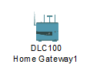

Door/Garage Door: Affects Argon, Carbon Monoxide, Carbon Dioxide, Hydrogen, Helium, Methane, Nitrogen, O2, Ozone, Propane, and Smoke. When the door is opened, those gases will decrease to a maximum of 2% in total change. When the door is opened, the rate of transference for Humidity and Temperature is increased by 25%. The rate of transference for gases is increased by 100%.



Smoke Detector: Detects Smoke. Alarm will go off when it detects the environment variable SMOKE at the level of 40%.

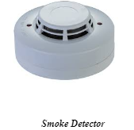

Fire Sprinkler: Raises the water level. Affects Water Level at a rate of 0.1 cm per second. This is connected to the smoke detector.

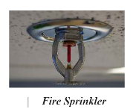

Siren: Makes a loud emergency noise when activated. It is activated when certain conditions are encountered.

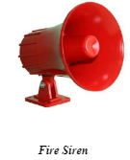

Smartphone: This is the user interface that allows the user to know that a fire occurred at their place with the help of the application running on their smartphone and the amount of smoke generated and hence take necessary steps.

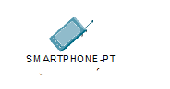

Window: A window is an opening in a wall, door, roof or vehicle that allows the passage of light, sound, and sometimes air.



Siren: Siren buzzes warning when the fire is detected.

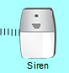

Table.1 Components of Proposed IOT Based Smoke Detector and Fire Prevention Device

________________________________________________________________________________

Components Name Hardware/Software

________________________________________________________________________________

1 Lawn Sprinkler Hardware

2 Siren Hardware

3 Door Hardware

4 Window Hardware

5 Garage Door Hardware

6 Smoke Detector Hardware

This project is based on the Hardware & Software experimental-setup.

*Table.1 Components of Proposed Smoke Detector and Fire Prevention System*

|  |  |  |
| --- | --- | --- |
| Components | Name | Hardware/Software |
| 1 | Fire Sprinkler | Hardware |
| 2 | Siren | Hardware |
| 3 | Door | Hardware |
| 4 | Window | Hardware |
| 5 | Garage Door | Hardware |
| 6 | Smoke Detector | Hardware |
| 7 | All type of Connections | Software |
| 8 | All type of Configurations | Software |

Procedure:

e have used home gateway which connects LAN to WAN

•All the IP addresses are addressed dynamically. For this we are using DHCP which

automatically allocates the IP address

•We are using home gateway. Each and every device is connected to it wirelessly

•We have set a certain threshold for the smoke detector. If it crosses that threshold then all

the components (Siren, fire sprinkler etc.) will get activated

•The threshold value for smoke detector is 0.5, If it crosses that level then siren, fire

sprinkler, door will be locked, window, garage door will be opened.

•This decreases the level of smoke intensity

* We have used home gateway which connects LAN to WAN.
* All the IP addresses are addressed dynamically. For this we are using DHCP which automatically allocates the IP address.
* We are using home gateway. Each and every device is connected to it wirelessly.
* We have set a certain threshold for the smoke detector. If it crosses that threshold then all the components (Siren, fire sprinkler etc.) will get activated.
* The threshold value for smoke detector is 0.5, If it crosses that level then siren, fire sprinkler, door will be locked, window, garage door will be opened. This decreases the level of smoke intensity.

1. *Implementation* 
   1. Network Design

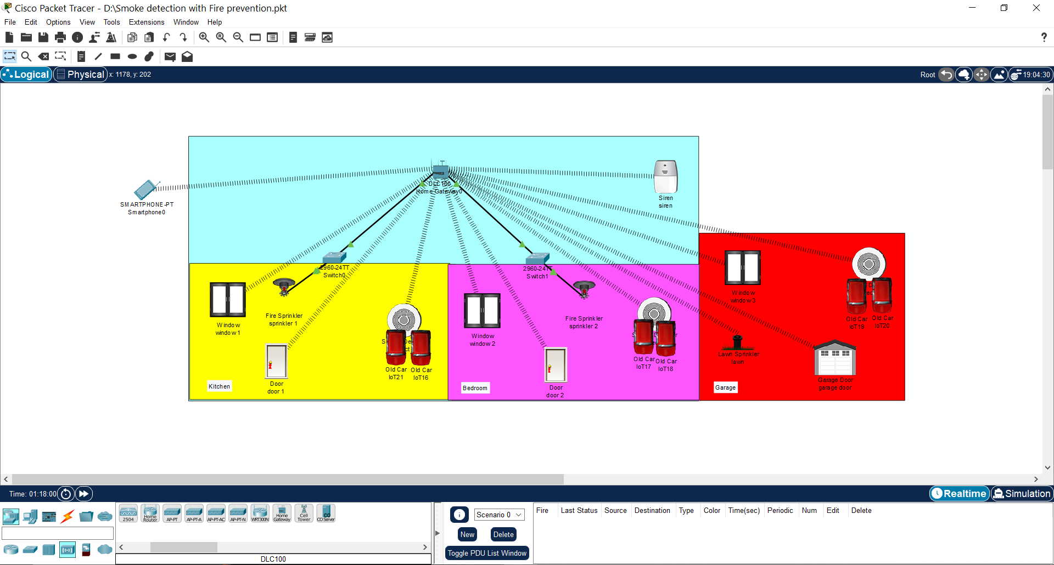

*Fig 6.1. Network Design*

* 1. Configuration

1. DLC Home Gateway

• Created a web page with username and password to connect and gain control of the system.

• Registration can be done on this router.

• Range of the router is set to maximum (1000 meters or 1km).

• Ip address is assigned as 192.168.25.1 dynamically.

1. Smartphone

• Connect to the system by going to the web browser and entering the IP of the registration server and logging in using ID and Password.

• Ip address is assigned as 192.168.25.120 dynamically.

1. Smoke Detector

• Smoke Detector is used to detect any smoke. E.g. When a fire breaks out the smoke detector will detect it. And in our project when the smoke level goes beyond 0.5, certain conditions are triggered such as door, windows are opened and fire sprinkler and siren are turned on.

• It is connected to Home Gateway using advanced setting in I/O config i.e. (PT-IOT-NM-1W) network adapter setting.

• Dynamic IP address is assigned using DHCP.

1. Window

• A window is an opening in a wall that allows the passage of light, sound, and sometimes air.

• It is connected to Home Gateway using advanced setting in I/O config i.e (PT-IOT-NM-1W) network adapter setting.

• Dynamic IP address is assigned using DHCP.

1. Door

• A door is an opening from where people can enter or leave in a normal routine life as well as in emergency.

• It is connected to Home Gateway using advanced setting in I/O config i.e (PT-IOT-NM-1W) network adapter setting.

• Dynamic IP address is assigned using DHCP.

1. Garage door

• A Garage door is an opening from where vehicles can enter or leave. In our case this is very crucial as garage doors are huge and can help the air escape when there is a fire outbreak, releasing carbon dioxide and other Smoke Detection and Fire Prevention gases into the air and helping any people to take clean air if they are stuck in the house.

• It is connected to Home Gateway using advanced setting in I/O config i.e. (PT-IOT-NM-1W) network adapter setting.

• Dynamic IP address is assigned using DHCP.

1. Fire sprinkler

• The fire sprinkler sprays streams of water to suppress or extinguish the fire when ordered by the home gateway. This happens when smoke detector detects smoke level more than 0.5.

• It is connected to Home Gateway using advanced setting in I/O config i.e (PT-IOT-NM-1W) network adapter setting.

• Dynamic IP address is assigned using DHCP.

1. Siren

• A siren is device which makes a loud emergency sound when the smoke detector detects smoke level greater than 0.5.

• It is connected to Home Gateway using advanced setting in I/O config i.e (PT-IOT-NM-1W) network adapter setting.

• Dynamic IP address is assigned using DHCP.

1. Car

• In Cisco-packet tracer there is no object or entity which can simulate the generation of smoke other than a car. So, we have used cars to represent smoke generation which is similar to smoke generated during fire.

* 1. Conditions

To implement the project, we need to specify certain conditions on which all the devices can be activated and deactivated. Based on how and when these conditions change, there will be changes in the state of the devices. To simulate smoke, we have used cars. The conditions which are mentioned above and are crucial for this simulation are as follows:

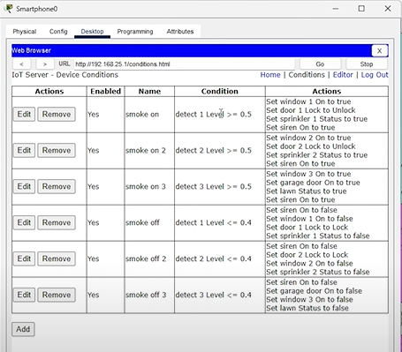

*Fig 6.2. System Conditions based on Situation*

1. *Result Analysis* 
   1. When smoke level is less than 0.5

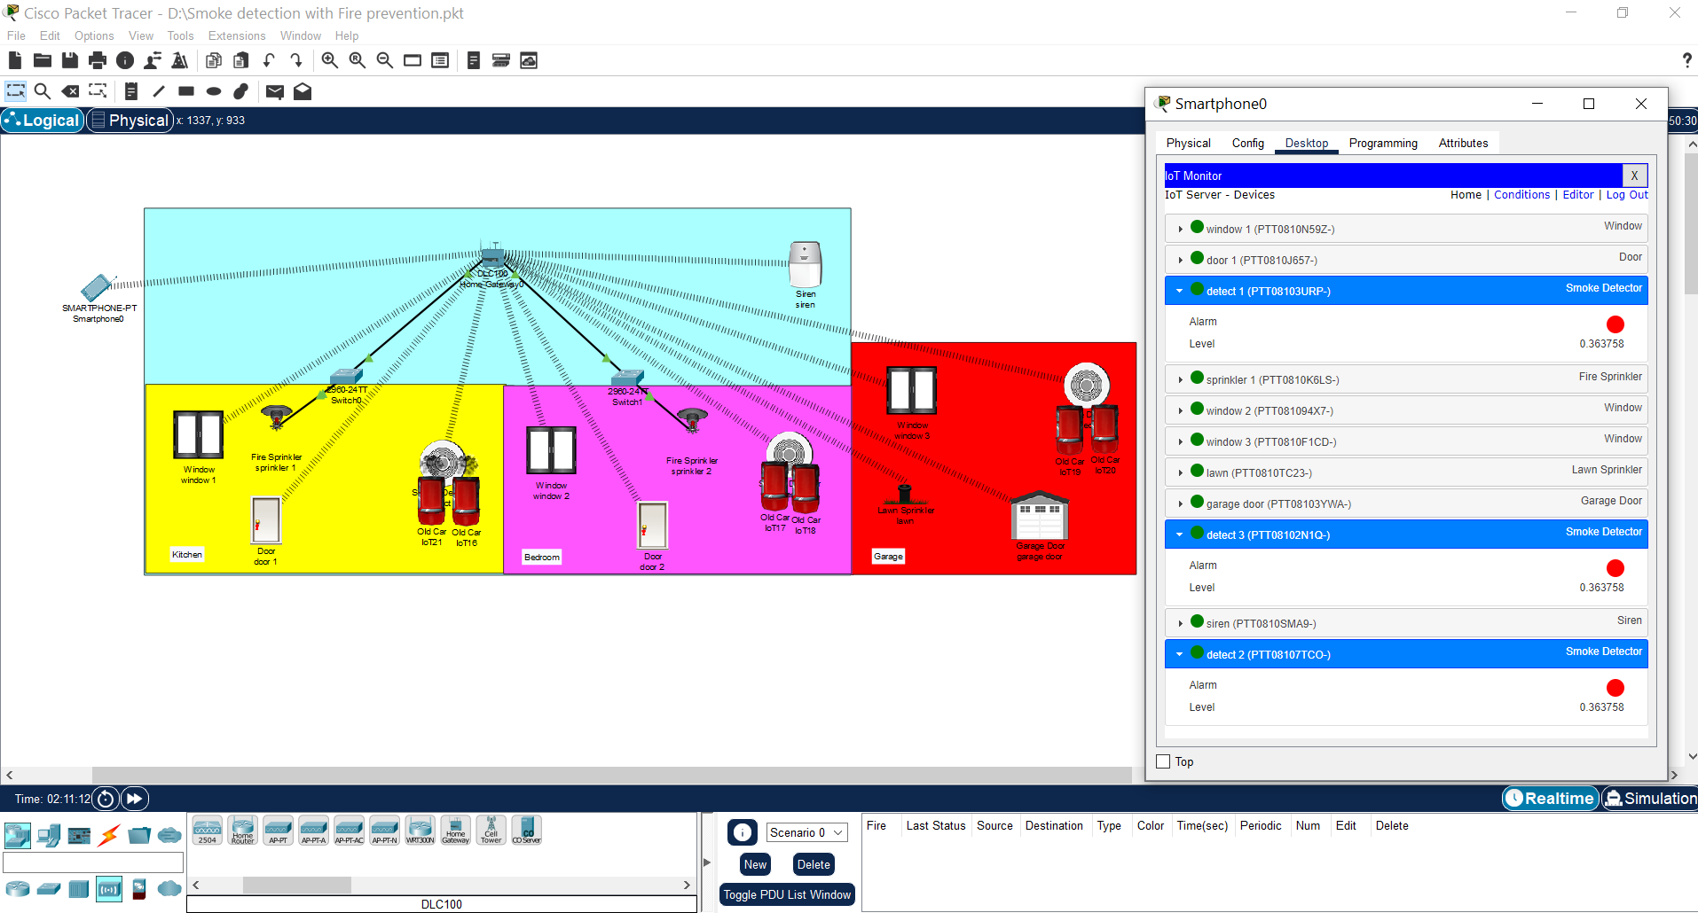

*Fig 7.1. System when fire not detected*

When the smoke detector detects smoke level less than 0.5, we can clearly see that fire was not detected by the system; and thus, no action will be taken by the system.

When the Condition Value i.e., is PM<0.3, We can clearly see that fire was not detected by the

system; and thus, no action will be taken by the system

When the Condition Value i.e., is PM<0.3, We can clearly see that fire was not detected by the

system; and thus, no action will be taken by the system

When the Condition Value i.e., is PM<0.3, We can clearly see that fire was not detected by the

system; and thus, no action will be taken by the system

When the Condition Value i.e., is PM<0.3, We can clearly see that fire was not detected by the

system; and thus, no action will be taken by the system

When the Condition Value i.e., is PM<0.3, We can clearly see that fire was not detected by the

system; and thus, no action will be taken by the systWhen the smoke detector detects smoke less than 0.5, we can clearly see that fire was not detected by the system; and thus, no action will be taken by the system.

* 1. When smoke level is more than 0.5

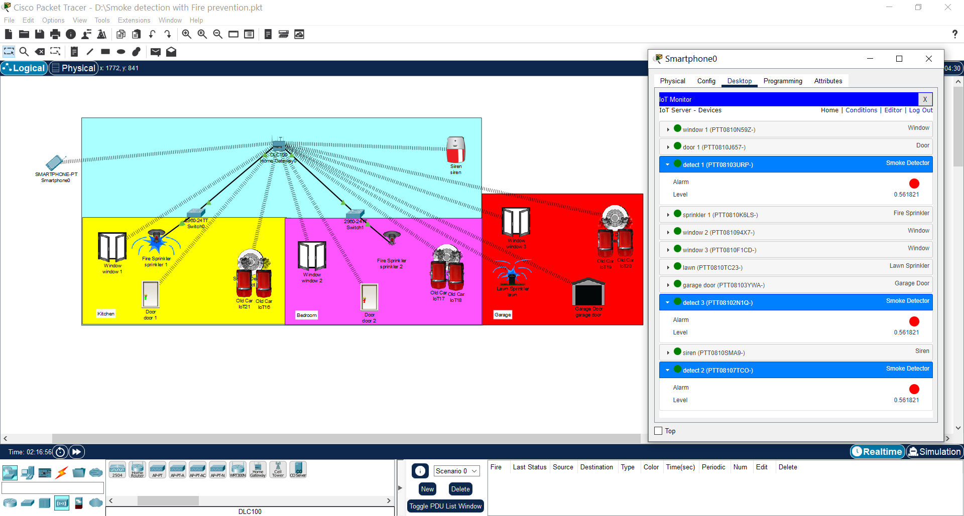

*Fig 7.2. System when fire detected*

When the smoke detector detects smoke level more than 0.5, we can clearly see that fire was detected by the system, and the programed instruction like opening doors, ringing of siren etc., will be executed by the system.

1. *Conclusion*

In conclusion, the project "Smoke Detection with Fire Prevention using Cisco Packet Tracer" successfully demonstrated the implementation of a reliable smoke detection and fire prevention system. Through the integration of smoke detectors, alert notification mechanisms, and fire prevention measures, the system showcased its ability to promptly detect smoke, alert relevant stakeholders, and take preventive actions to minimize potential damage and risks. The use of Cisco Packet Tracer facilitated the design, simulation, and testing of the network infrastructure, ensuring accurate representation and effective troubleshooting. The project's scalability and flexibility allowed for easy adaptation to different building layouts, while its modular design facilitated the integration of additional components as needed. Overall, this project serves as a valuable foundation for enhancing fire safety systems, emphasizing the importance of proactive measures in protecting lives and property from fire incidents.

1. *References*
2. <https://www.studocu.com/in/document/siksha-o-anusandhan-university/computer-networking/cn-course-based-project/44237454>
3. [Packet Tracer 8.2- IoT devices configuration - Packet Tracer Network](https://www.packettracernetwork.com/internet-of-things/pt7-iot-devices-configuration.html)
4. [Packet Tracer 8.0 - IoT advanced programming & automation - Packet Tracer Network](https://www.packettracernetwork.com/internet-of-things/iot-advanced-programming.html)